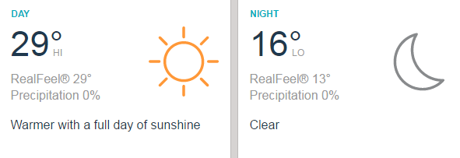
Prologue - Sunday March 19
Start location:
Meerendal Wine Estate
End location:
Meerendal Wine Estate

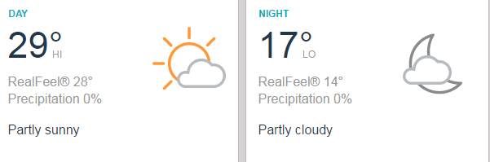
Stage one - Monday March 20
Start location:
Hermanus High School
End location:
Hermanus High school

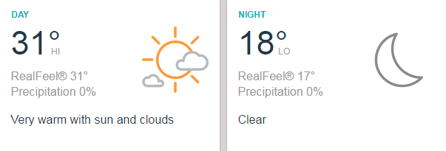
Stage two - Tuesday March 21
Start location:
Hermanus High School
End location:
Elandskloof

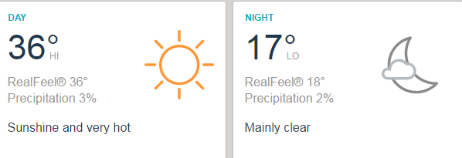
Stage three - Wednesday March 22
Start location:
Elandskloof
End location:
Elandskloof

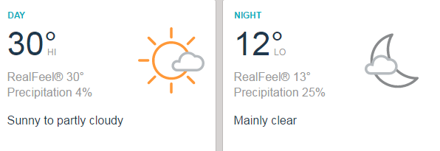
Stage four - Thursday March 23
Start location:
Elandskloof
End location:
Oak Valley

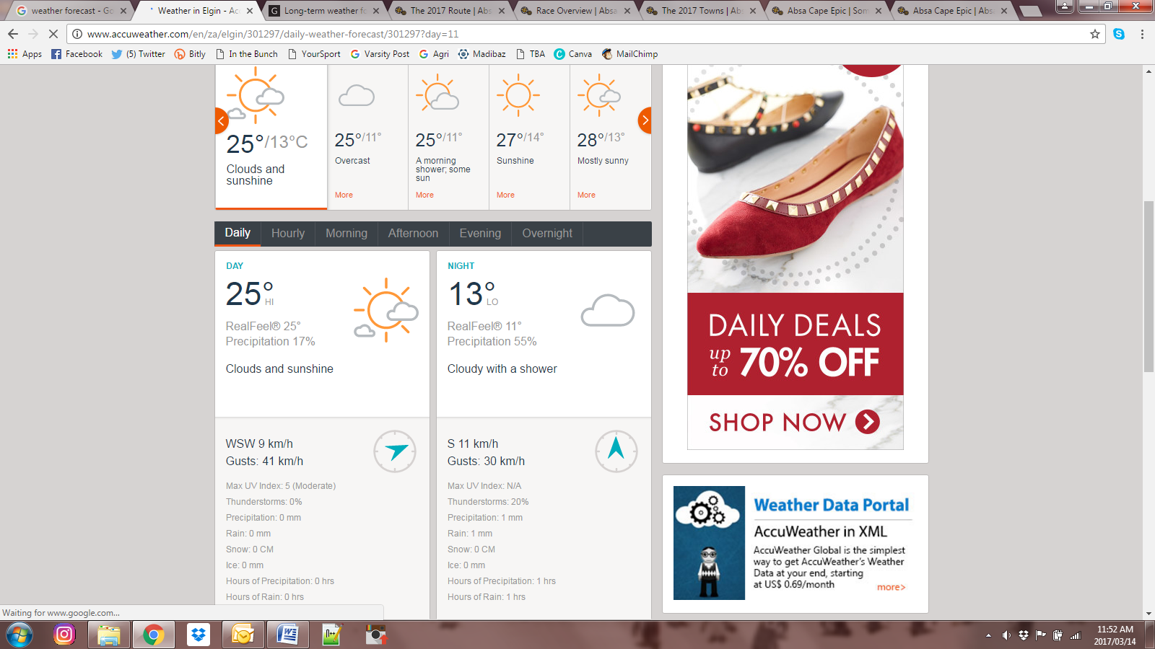
Stage five - Friday March 24
Start location:
Oak Valley
End location:
Oak Valley

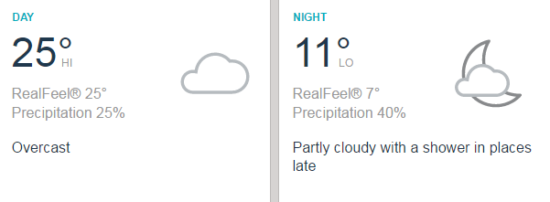
Stage six - Saturday March 25
Start location:
Oak Valley
End location:
Oak Valley

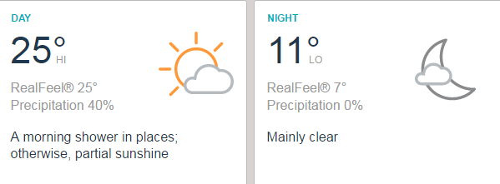
Stage seven - Sunday March 26
Start location:
Oak Valley
End location:
Val die Vie

Forecast courtesy of AccuWeather

